**Edit Patient Button**

The Edit button is on the patients_datatable form. identified by class=”patient-edit”.

**Description:** When the Edit button is pressed, an Ajax call is made to /Patients/Edit (**/Controllers/PatientController**)

The Action method executes a query on the database by calling **FindPatientWithRelationsByIdAsync** on the **PatientManager** controller helper class, which does an eager load of all the data for the particular patient into a **Patient** class object which is then passed to the partial view **/Views/Patients/Edit/Edit.cshtml** together with Viewbag data containing the dropdown options which is made available to the view. The view is then rendered and passed back via the Ajax call as html which is then displayed in the modal-container.

**The jquery click** event on this button is set by **bindPatientEdit** function in **wwwroot/js/Patient.js**

**[Patient.js]**

**var bindPatientEdit** = function () {

$(document).off("click.patient-edit").on("click.patient-edit", "a.patient-edit", function (e) {

LoadingIndicator.show(); Show loading spinner

e.preventDefault();

$.get($(this).attr("href"), function (responseHtml) { Ajax call href on Edit button is /Patients/Edit/Id

LoadingIndicator.hide();

$("div#modal-container").html(responseHtml); response back is html send to modal-container

$("div#edit-modal").modal("show"); show modal-container

//$.validator.unobtrusive.parse("form#edit-patient-form");

updatePatient(); set event for update-patient button on modal form

onPatientStatusChange(); Set change event on PatientStatus control shows death date

initPatientsDateTimePickers(); Set datetime pickers

$("select.select2").select2({ jquey Select2 Selectors used for multi select dropdowns

minimumResultsForSearch: -1,

placeholder: function () {

$(this).data('placeholder');

}

});

$("select.select2-search").selectize(); jquey Select2 Selectors used for multi select dropdowns

$("select[multiple='multiple']").multiSelect();

CaseReportForms.onPatientCaseReportFormSelectChange();

CaseReportForms.deletePartialFromPopup();

deletePartialFromPopup();

onPatientStatusChange();

AllergyIntolerance.init(); From www/js/AllergyIntolerance.js

$("select.selectize, select.select2-search").selectize();

UI.initAjaxTab(); From wwwroot/js/UI.js

});

});

};

When button clicked Ajax get to Patients/Edit/(int?id) and puts returned html into the modal-container.

Returns:

**return PartialView(patient);**

The **\Views\Patients\Edit.cshtml** contains a host of nested partial views:

**@Html.Partial("~/Views/Patients/Edit/_Edit.cshtml")**

So creates an html view made up of a whole series of partial views as the trace below displays:

This shows a tabbed form **/Views/Patients/Edit/_DetailsTab.cshtml**

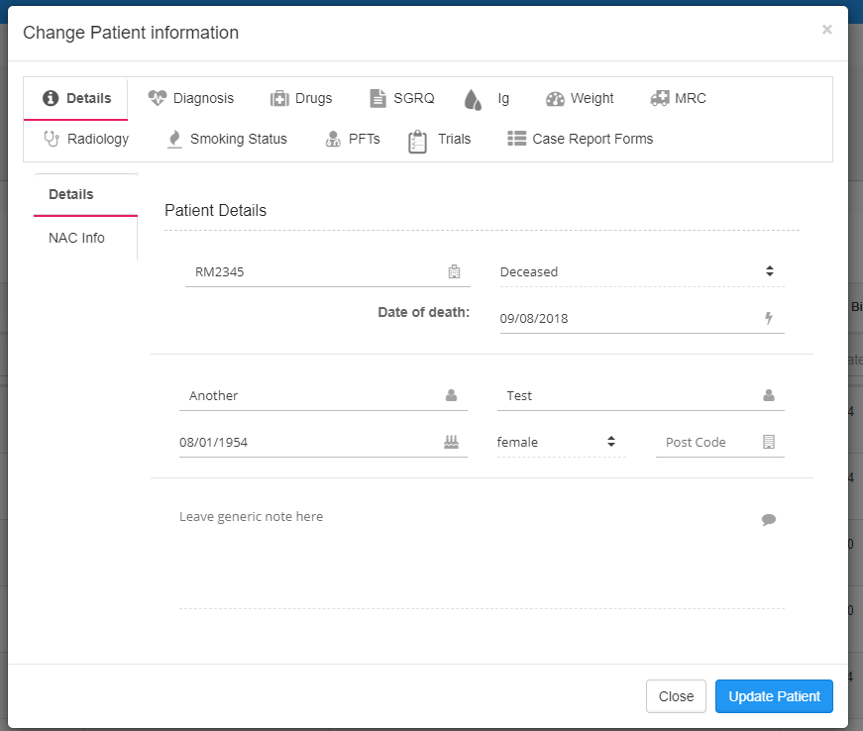

Hierarchy of partial views rendered from **Patients/Edit.cshtml** ::

**Views/Patients/Edit.cshtml**

**/Views/Patients/Edit/_Edit.cshtml** => Displays tabbed modal Form includes Update Patient button

**/Views/Patients/Edit/_DetailsTab.cshtml**

**/Views/Patients/Edit/_PatientDetails.cshtml**

**/Views/Patients/Edit/_NacInfo.cshtml**

**/Views/Patients/Edit/_DiagnosesTab.cshtml**

**/Views/Patients/Edit/_DiseasesTab.cshtml**

**/Views/Patients/Edit/_SurgeriesTab.cshtml**

**/Views/Patients/Edit/_AllergyIntoleranceItems.cshtml**

**/Views/Patients/Edit/_DrugsTab.cshtml**

**/Views/Patients/Edit/_DrugsMonitoring.cshtml**

**/Views/Patients/Edit/_DrugLevels.cshtml**

**/Views/Patients/Edit/_STGQuestionnaire.cshtml**

**/Views/Patients/Edit/_IgTab.cshtml**

**/Views/Patients/Measurements/_Edit.cshtml** => Height/Weight

**/Views/Patients/MRCScores/_Edit.cshtml**

**/Views/Patients/Edit/_RadiologyTab.cshtml**

**/Views/Patients/SmokingStatuses/_Details.cshtml**

**/Views/Patients/PulmonaryFunctionTests/_Details.cshtml**

**/Views/Patients/Edit/_MedicalTrials.cshtml**

**/Views/Patients/CaseReportForms/_Edit.cshtml**

Some of the tabbed forms seem to be treated differently.

Not all the partial forms are loaded into the DOM on the first ajax download. Some are not downloaded until the tab is clicked. Don’t know why at moment.

Height/Weight

href=/patients/id/Measurement/Edit

MRC

href=/patients/id/MRCScores/Edit

PFTs

href=/patients/id/PFTs/Edit

Smoking Status

href=/patients/id/SmokingStatuses/Edit

**The jquery click** event on **Update Patient** button on the tabbed modal form has its click event set by Patient.js

Posts form data back **to /patients/edit/id**

**[Patient.js]**

**var updatePatient** = function () {

$(document).off("click.update-patient").on("click.update-patient", "button.update-patient", function (e) {

$("label.text-danger").remove();

LoadingIndicator.show();

e.preventDefault();

$.ajax({

url: $("form#edit-patient-form").attr("action"), action attribute is /patients/edit/id, but for POST

type: "POST",

data: $("form#edit-patient-form").serialize(), Creates a properly formatted and encoded query string of form data

contentType: "application/x-www-form-urlencoded",

dataType: 'json' Send JSON encoded data

}).done(function (data, textStatus) {

LoadingIndicator.hide();

if (textStatus === "success") {

if (data.errors) {

displayUpdateErrors(data.errors);

} else {

$("form#edit-patient-form")[0].reset();

$("div#edit-modal").modal("hide");

window.patientsTable.ajax.reload(function () {

currentUserWithRoles();

});

}

}

}).fail(function (data) {

LoadingIndicator.hide();

$("form#edit-patient-form")[0].reset();

$("div#edit-modal").modal("hide");

alert("There was a problem saving this patient. Please contact administrator");

});

});

}

Ajax Post back to **Patient/Edit(params List)** action method decorated with [HttpPost]

[Authorize(Roles = ("Admin Role, Update Role"))]

[HttpPost, ActionName("Edit")]

[ValidateAntiForgeryToken]

public async Task<IActionResult> EditPatient(int? id, [Bind("ID,DiagnosisCategoryId,DiagnosisTypeId,Description")] PatientDiagnosis[] diagnoses,

[Bind("ID,DrugId,StartDate,EndDate")] PatientDrug[] drugs,

[Bind("ID, ActivityScore, SymptomScore, ImpactScore, TotalScore")] PatientSTGQuestionnaire[] sTGQuestionnaires,

[Bind("ID, DateTaken, Value, ImmunoglobulinTypeId")] PatientImmunoglobulin[] patientImmunoglobulines,

[Bind("ID, DateTaken, FindingId, RadiologyTypeId, ChestLocationId, ChestDistributionId, GradeId, TreatmentResponseId, Note")] PatientRadiologyFinding[] radiololgyFindings,

[Bind("ID, PatientId, MedicalTrialId, PatientMedicalTrialStatusId, IdentifiedDate, ConsentedDate, RecruitedDate, Consented")] PatientMedicalTrial[] patientMedicalTrial,

[Bind("ID, PatientId, DrugId, UnitOfMeasurementId, DateTaken, DateReceived, ResultValue, ComparisionCharacter")] PatientDrugLevel[] drugLevels,

[Bind("ID, SurgeryId, PatientId, SurgeryDate, Note")] PatientSurgery[] surgeries,

[Bind("ID, AllergyIntoleranceItemType, AllergyIntoleranceItemId, IntoleranceType, Severity, Note")] PatientAllergicIntoleranceItem[] allergies,

[Bind("ID, PulmonaryFunctionTestId, Value, ResultValue, PatientId")]PatientPulmonaryFunctionTest[] pulmonaryFunctionTest,

[Bind("ID, FirstSeenAtNAC, CPABand, ReferralDate, LastObservationPoint, InitialDrug, FollowUp3MonthsDrug, PatientId")] PatientNACDates patientNACDates,

[Bind("ID, DateTaken, Weight, Height")] PatientMeasurement[] patientMeasurements,

[Bind("ID, DateTaken, Score")] PatientMRCScore[] patientMRCScores,

[Bind("ID, SmokingStatusId, PatientId, StartAge, StopAge, CigarettesPerDay, PacksPerYear, AlcolholUnits")] PatientSmokingDrinkingStatus patientSmokingDrinkingStatus,

CaseReportFormResult[] caseReportFormResult)

The incoming values from the Http Form values are explicitly bound to various model objects and arrays of model objcts.

The data for the patient in question in then loaded into memory using the **PatientManager** helper controller:

Patient patientToUpdate = await _patientManager .FindPatientWithFirstLevelRelationsByIdAsync(id);

The EF entity ModelState l for patientToUpdate is then updated with the input values again by action methods from

**PatientManager** and thenthe data is written back to the database via

**_context.SaveChanges();**

If there are no ModelState errors the program closes the modal and returns to the main Patient Table.

**TODO: If there are errors when changes are saved the modal form stays open and the problem fields are underlined in red. Unfortunately, if the errors are on tabs not in view, you cant see the problem. Need to fix this.**